Full Stack Development with MERN
Project Documentation format
1. Introduction
Project Title: Cafeteria Menu Display
Team Members:
Team ID : LTVIP2026TMIDS66321
Team Size : 4
Team Leader : Kalimandla Soniya
Team member : Rachamreddy Suhasini
Team member : Pagidi Shashank
Team member : T.Naga Sushma

2. Project Overview
•Purpose:
The Cafeteria Menu Display Portal is designed to manage, publish, and display daily and weekly cafeteria menus efficiently across an organization. It enables administrators to create, approve, and schedule menus while allowing employees to view real-time meal options, dietary choices, and special offerings.
Key Features:
- Create and manage cafeteria menus
- Schedule menus by date
- Publish menus for employee viewing
- Service Catalog submission for new menus
- Automated approval and publishing workflow
- Reports and dashboard integration
- Historical menu tracking

3. Architecture
This project is built using the ServiceNow platform, which provides built-in frontend, backend, database, and workflow capabilities.
Frontend (Portal/UI)
- Uses ServiceNow forms and Service Portal UI
- Employees interact through Service Catalog
- Admins manage menus via table forms
- Dashboard displays reports
Backend (Business Logic)
- Implemented using ServiceNow server-side scripting
- UI Actions automate publishing workflow
- Business rules manage data processing
Database (Tables)
Custom table: Cafeteria Menu Display
Fields include:
- Menu Name
- Menu Date
- Menu Items
- Status (Draft/Published)

4. Setup Instructions
Prerequisites
- ServiceNow instance access
- Admin role permissions
- Web browser
Installation / Configuration Steps
- Log in to ServiceNow instance
- Create a new application:
  - Name: Cafeteria Menu Display
- Create custom table under System Definition
- Add fields: Menu Name, Date, Items, Status
- Create Service Catalog item
- Configure variables for menu submission
- Create reports and dashboards
- Add UI Action for publishing menus

5. Folder Structure (Conceptual in ServiceNow)
Client Side (User Interface)
- Service Portal Pages
- Catalog Item Forms
- Dashboard Widgets
Server Side (Backend Components)
- Custom Tables
- UI Actions
- Business Rules
- Reports
- Workflows

6. Running the Application
Since this is a ServiceNow cloud application, no local server setup is required.
To use the system:
- Open ServiceNow instance
- Navigate to Service Catalog → Submit New Cafeteria Menu
- Admins manage menus via Cafeteria Menu table

7. API Documentation (Conceptual)
ServiceNow provides REST APIs automatically.
Example Operations
Create Menu
- Method: POST
- Endpoint: /api/now/table/cafeteria_menu
- Parameters: Menu Name, Date, Items
Retrieve Menus
- Method: GET
- Returns list of menus
Update Status
- Method: PUT/PATCH
- Used when marking menu as Published

8. Authentication
- Handled by ServiceNow user authentication
- Role-based access control (RBAC)
- Only admins can create/publish menus
- Employees have read-only access

9. User Interface
Key UI Components:
- Service Catalog form to submit menu
- Table view for administrators
- “Mark as Published” button (UI Action)
- Dashboard with reports
- 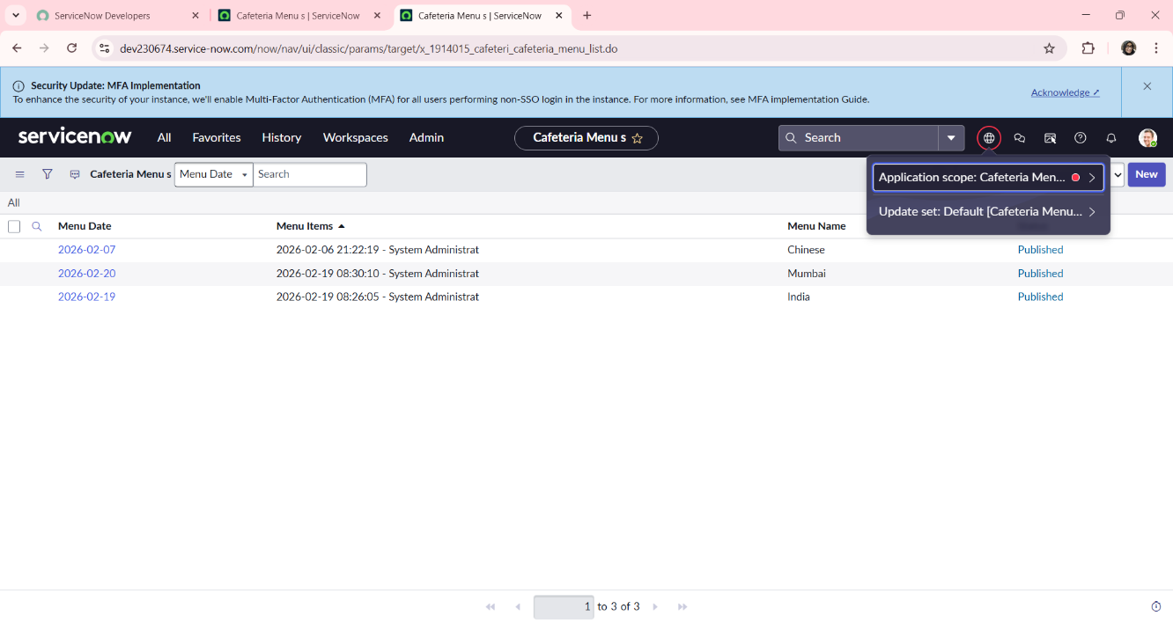

10. Testing
Testing was performed using:
- Manual functional testing
- Catalog submission testing
- UI Action testing
- Report generation validation
Test Cases Included:
- Creating new menu
- Publishing menu
- Viewing menu as employee
- Report accuracy

11. Screenshots or Demo
Include screenshots of:
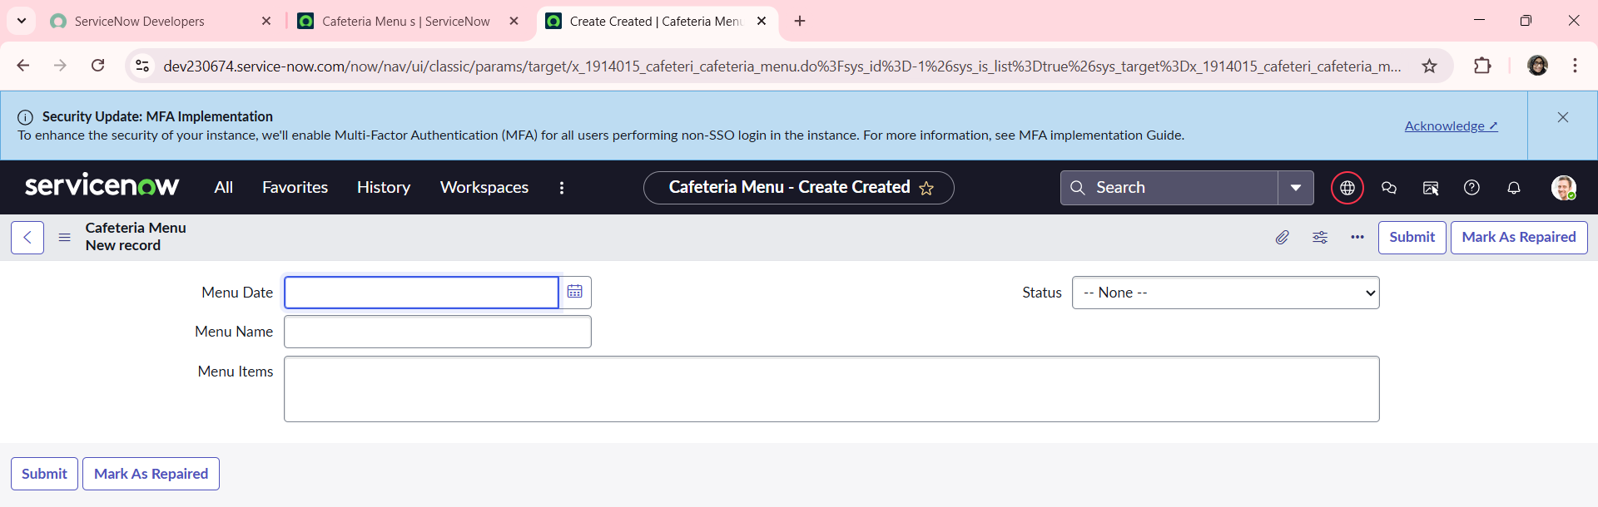

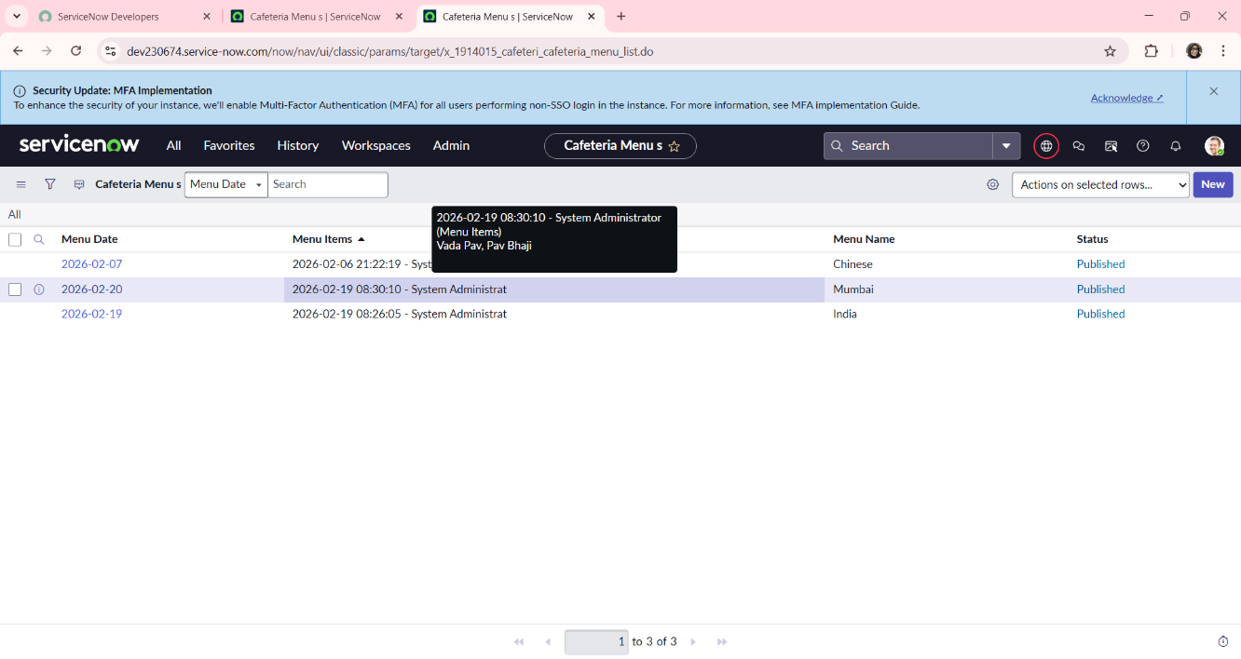
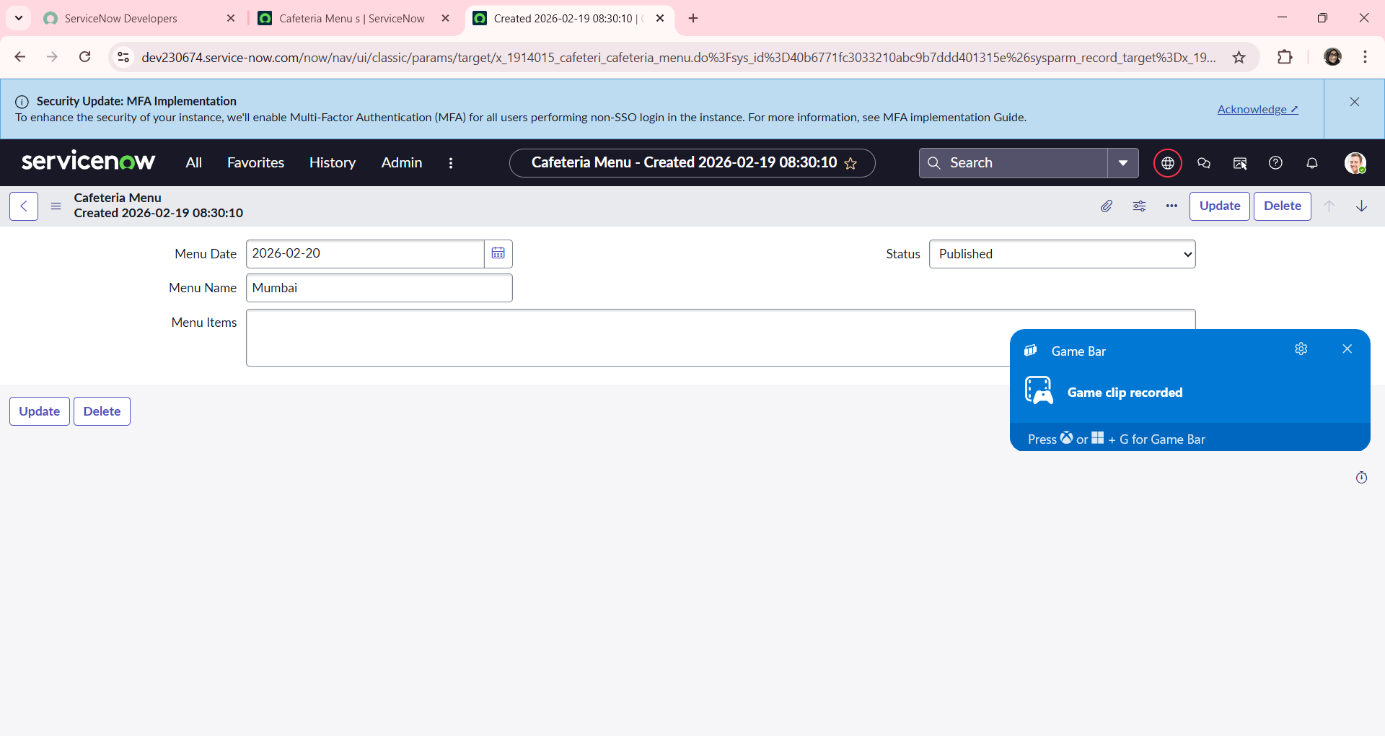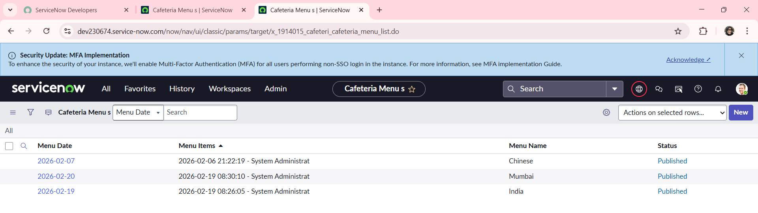

12. Known Issues
- No automated approval workflow (manual publishing required)
- Limited dietary filtering options
- No mobile-optimized portal design
- Depends on ServiceNow instance availability

13. Future Enhancements
Possible improvements:
- Mobile app integration
- Automated approval workflow
- Dietary filters (Veg/Non-Veg/Vegan/Allergens)
- Email/SMS notifications for new menus
- AI-based meal recommendations
- Feedback and rating system for meals

